LAB 4 : Introduction to Packet Tracer: Basic Router Configuration

Objective(s)
• To understand and practice basic router and switch configuration commands in Cisco Packet Tracer.
• To secure router access using passwords and encryption.
• To configure interfaces, VLAN, and verify connectivity between devices.
Background
Packet Tracer is a powerful network simulator that can be utilized in training for network
certification like and learning by allowing students to create networks with an almost
unlimited number of devices and to experience troubleshooting without having to buy
real Cisco routers or switches. The tool is created by Cisco Systems. The purpose of Packet
Tracer is to offer students a tool to learn the principles of networking.

Prompt | Mode Description
Router> | User mode
Router# | Privileged mode
Router(config)# | Global configuration mode
Router(config-if)# | Interface mode
Router(config-subif)# | Subinterface mode
Router(config-line)# | Line mode
Router(config-router)# | Router configuration mode

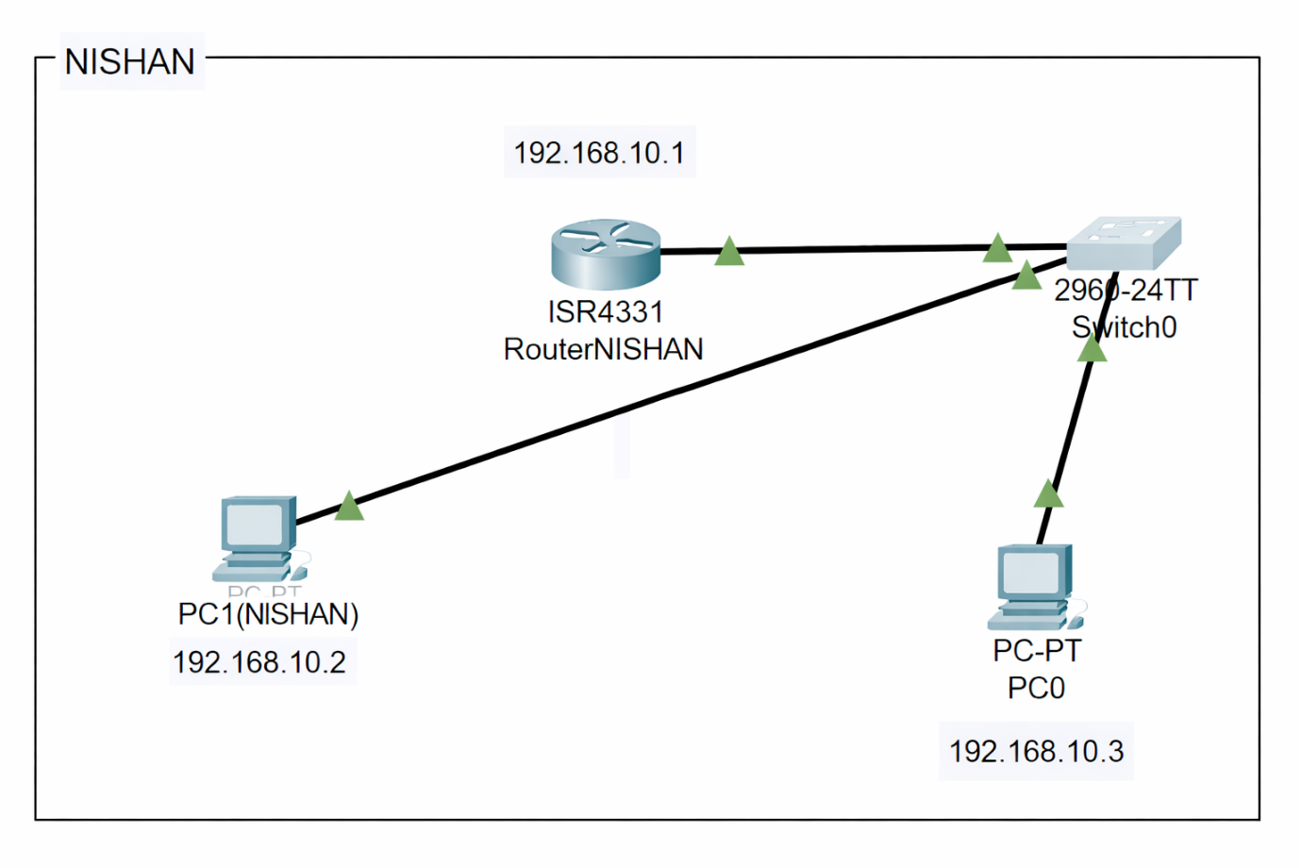

Router Configuration
Router>enable
Router#configure terminal
Enter configuration commands, one per line. End with CNTL/Z.
Router(config)#hostname Nishan
Nishan (config)#enable password cisco
Nishan(config)#enable secret class
Nishan(config)#line console 0
Nishan(config-line)#password cisco
Nishan(config-line)#login
Nishan(config-line)#exit
Nishan(config)#line vty 0 4
Nishan(config-line)#password cisco
Nishan(config-line)#login
Nishan(config-line)#exit
Nishan(config)#service password-encryption
Nishan(config)#exit
Nishan#
Nishan#configure terminal
Enter configuration commands, one per line. End with CNTL/Z.
Nishan(config)#service password-encryption
Nishan(config)#exit
Nishan#
%SYS-5-CONFIG_I: Configured from console by console
Nishan#clock ?
set Set the time and date
Nishan#clock set?
set
Nishan#clock set ?
hh:mm:ss Current Time
Nishan#clock set 11:11:11 ?
<1-31> Day of the month
MONTH Month of the year
Nishan#clock set 11:11:11 oct
% Incomplete command.
Nishan#clock set 11:11:11 oct ?
<1-31> Day of the month
Nishan#clock set 11:11:11 oct 30 ?
<1993-2035> Year
Nishan#clock set 11:11:11 oct 30 2004
Nishan#configure terminal
Enter configuration commands, one per line. End with CNTL/Z.
Nishan(config)#banner motd $ UNATHORISED ACCESS RESTRICTED $
Nishan(config)#interface GigabitEthernet0/0/0
Nishan(config-if)#ip address 192.168.1.1 255.255.255.0
Nishan(config-if)#ip address 192.168.1.1 255.255.255.0
Nishan(config-if)#no shutdown
Nishan(config-if)#
%LINK-5-CHANGED: Interface GigabitEthernet0/0/0, changed state to up
%LINEPROTO-5-UPDOWN: Line protocol on Interface GigabitEthernet0/0/0, changed state to up
Nishan(config-if)#exit
Nishan(config)#exit
Nishan#
%SYS-5-CONFIG_I: Configured from console by console
Nishan#copy running-config startup-config
Destination filename [startup-config]?
Building configuration...
[OK]

SWITCH CONFIGURATION
Switch>enable
Switch#configure terminal
Enter configuration commands, one per line. End with CNTL/Z.
Switch(config)#interface vlan 1
Switch(config-if)#ip address 192.168.1.4 255.255.255.0
Switch(config-if)#no shutdown

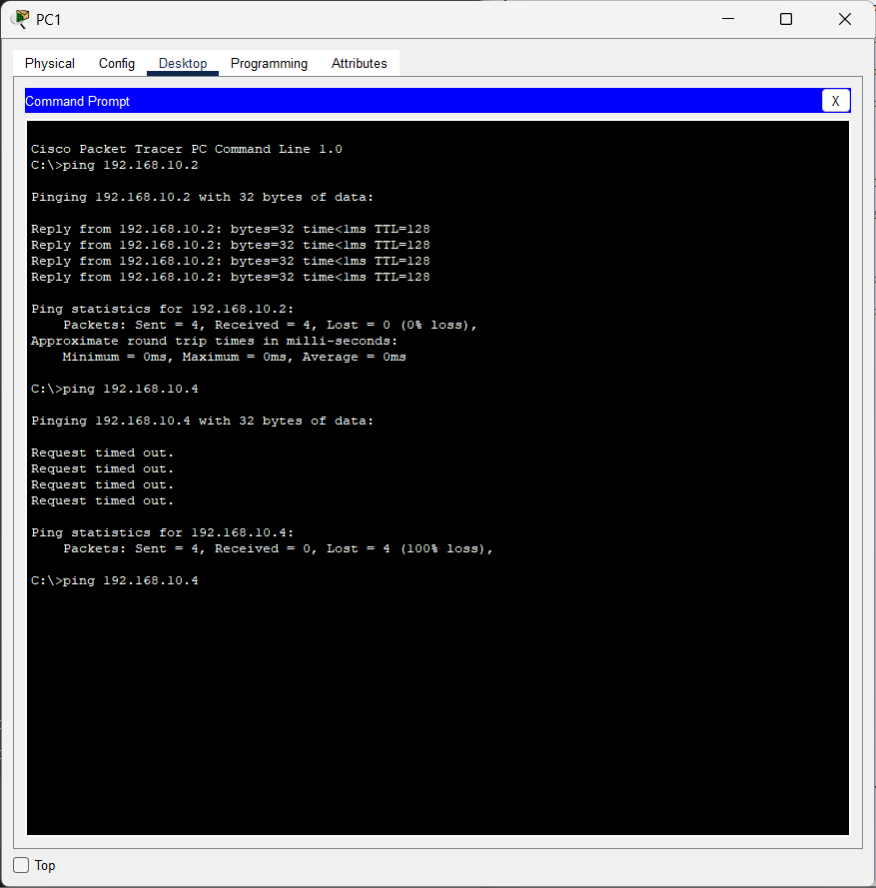

LAB 5: Static Routing Implementation

Objective
- Understand how Static Routing works
- Learn its advantages and disadvantages
- Configure static routes on routers

Background: Static Routing
Static routing is manually configured routing. It is ideal for small networks where the number of routes is limited.

Advantages
- Simple to configure
- Very secure (no routing updates shared)
- No CPU or memory overhead

Disadvantages
- Not scalable for large networks
- Cannot auto-reroute traffic when a link fails
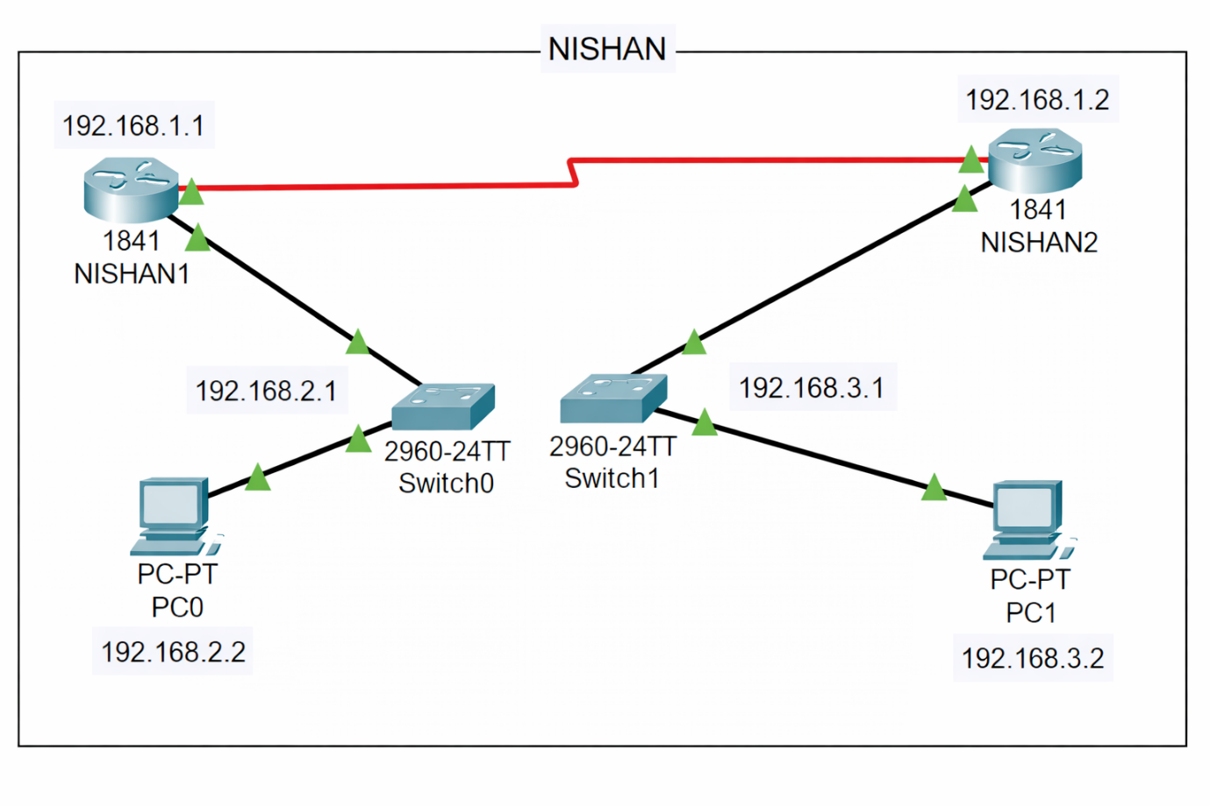

Basic Configuration of Routers
Router: NISHAN1
Router>enable
Router#configure terminal
Enter configuration commands, one per line. End with CNTL/Z.
Router(config)#hostname NISHAN1
NISHAN1(config)#
NISHAN1(config)#enable password cisco
NISHAN1(config)#enable secret class
NISHAN1(config)#line console 0
NISHAN1(config-line)#password cisco
NISHAN1(config-line)#login
NISHAN1(config-line)#line vty 0 15
NISHAN1(config-line)#password cisco
NISHAN1(config-line)#login
NISHAN1(config-line)#line aux 0
NISHAN1(config-line)#password cisco
NISHAN1(config-line)#login
NISHAN1(config-line)#exit
NISHAN1(config)#service password-encryption

Router Nishan2:
Router>enable
Router#configure terminal
Enter configuration commands, one per line. End with CNTL/Z.
Router(config)#hostname NISHAN2
NISHAN2(config)#
NISHAN2(config)#ENABLE password cisco
NISHAN2(config)#enable secret class
NISHAN2(config)#
NISHAN2(config)#line console 0
NISHAN2(config-line)#password cisco
NISHAN2(config-line)#login
NISHAN2(config-line)#
NISHAN2(config-line)#line vty 0 15
NISHAN2(config-line)#password cisco
NISHAN2(config-line)#login
NISHAN2(config-line)#
NISHAN2(config-line)#line aux 0
NISHAN2(config-line)#password cisco
NISHAN2(config-line)#login
NISHAN2(config-line)#exit
NISHAN2(config)#service password-encryption
NISHAN2(config)#
NISHAN2#
%SYS-5-CONFIG_I: Configured from console by console

2. Router Interface Configuration
Router 1(NISHAN1)
Serial Link
NISHAN1(config)#interface Serial0/1/0
NISHAN1(config-if)#description
NISHAN1(config-if)#description Link to NISHAN2
NISHAN1(config-if)#ip address 192.168.1.1 255.255.255.0
NISHAN1(config-if)#clock rate 64000
NISHAN1(config-if)#no shutdown
Fast Ethernet
NISHAN1(config)#interface FastEthernet0/0
NISHAN1(config-if)#ip address 192.168.2.1 255.255.255.0
NISHAN1(config-if)#no shutdown
Router 2(NISHAN2)
Serial Link
NISHAN1(config)#interface Serial0/1/0
NISHAN1(config-if)#description
NISHAN1(config-if)#des link from LAN to internet
NISHAN1(config-if)#ip address 192.168.1.2 255.255.255.0
NISHAN1(config-if)#clock rate 64000
NISHAN1(config-if)#no shutdown

Fast Ethernet
NISHAN2(config)#interface FastEthernet0/0
NISHAN2(config-if)#ip address 192.168.3.1 255.255.255.0
NISHAN2(config-if)#no shutdown

3. Routes Configuration
Router 1(NISHAN1)
NISHAN1(config)#ip route 192.168.3.0 255.255.255.0 192.168.1.2
Router 2(NISHAN2)
NISHAN2(config)#ip route 192.168.2.0 255.255.255.0 192.168.1.1

4.Result
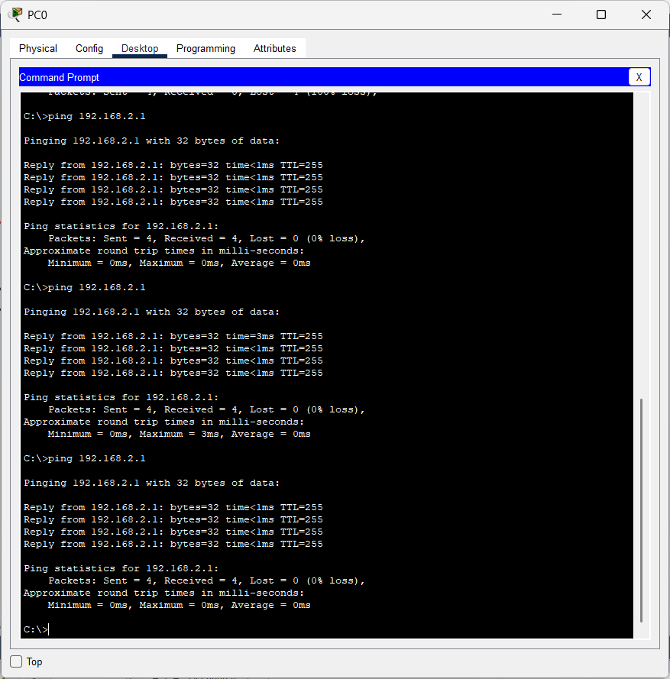

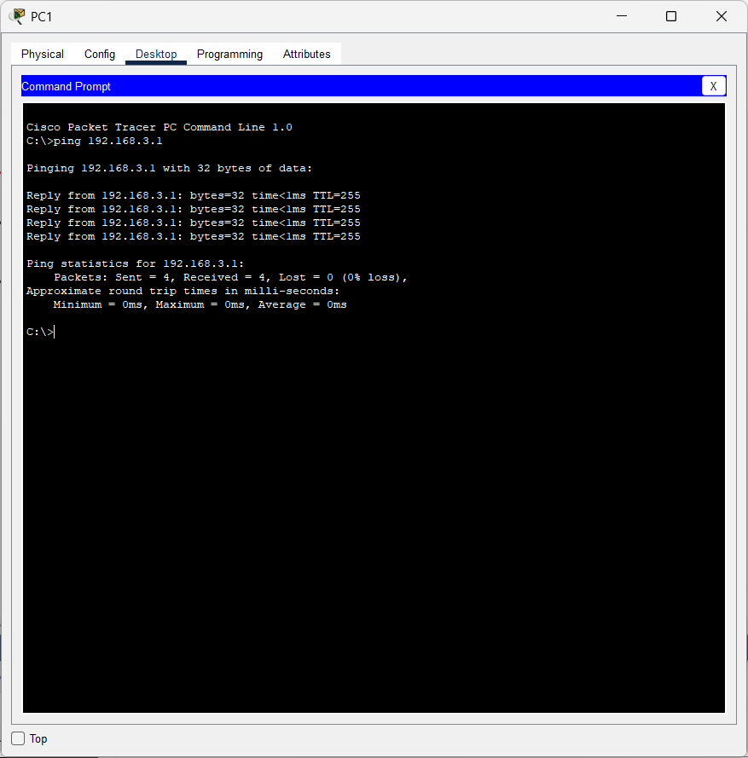

LAB 6: VLAN and VLAN Trunking.
Objective(s):
- Understand LAN segmentation using VLANs
- Create VLANs on multiple switches
- Configure Access Ports and Trunk Ports
- Assign IPs to hosts in different VLANs
- Verify inter-switch VLAN connectivity

Background
What is a VLAN?
A Virtual Local Area Network (VLAN) divides a physical network into logical sub-networks.
Devices in the same VLAN behave as if they are on the same LAN—even if connected to different switches.

Access Ports
- Connect end devices (PCs, printers)
- Carry traffic for only one VLAN
- Frames are not tagged

Trunk Ports
- Connect switches to switches
- Carry traffic for all VLANs
- Frames are tagged to specify VLAN
- Required for VLAN communication across switches

Native VLAN
- Default VLAN on a trunk (usually VLAN 1)
- Frames on native VLAN are not tagged

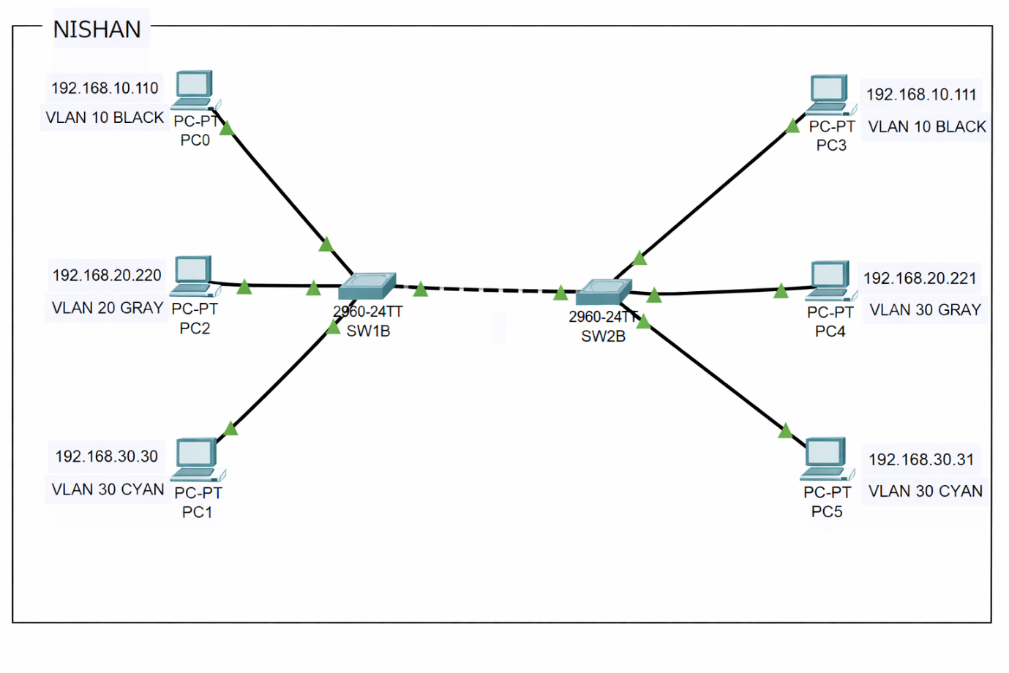
1.Configuration VLAN on Both Switches
Switch 1
Switch>enable
Switch#configure terminal
Enter configuration commands, one per line. End with CNTL/Z.
Switch(config)#hostname SW1B
SW1B(config)#
SW1B(config)#vlan 10
SW1B(config-vlan)#name BLACK
SW1B(config-vlan)#exit
SW1B(config)#vlan 20
SW1B(config-vlan)#name GRAY
SW1B(config-vlan)#exit
SW1B(config)#vlan 30
SW1B(config-vlan)#name CYAN
SW1B(config-vlan)#exit
SW1B(config)#exit

SW1B#show vlan brief
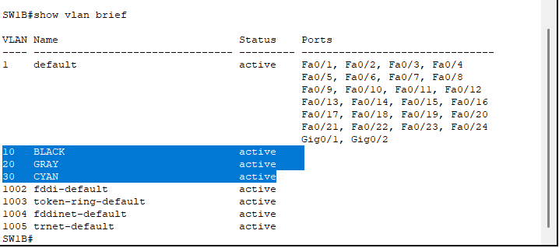

Switch 2

Switch>enable
Switch#configure terminal
Enter configuration commands, one per line. End with CNTL/Z.
Switch(config)#hostname SW2B
SW2B(config)#
SW2B(config)#vlan 10
SW2B(config-vlan)#name BLACK
SW2B(config-vlan)#EXIT
SW2B(config)#vlan 20
SW2B(config-vlan)#name GRAY
SW2B(config-vlan)#exit
SW2B(config)#vlan 30
SW2B(config-vlan)#name CYAN
SW2B(config-vlan)#EXIT
SW2B(config)#EXIT

SW2B#show vlan brief
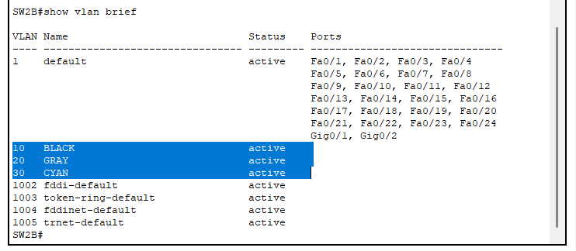

2. Configure Access Mode on both the Switches
Switch 1
SW1B(config)#interface FastEthernet0/2
SW1B(config-if)#switchport mode access
SW1B(config-if)#switchport access vlan 10
SW1B(config-if)#interface fastethernet 0/3
SW1B(config-if)#switchport mode access
SW1B(config-if)#switchport access vlan 20
SW1B(config-if)#interface fastethernet 0/4
SW1B(config-if)#switchport mode access
SW1B(config-if)#switchport access vlan 30
SW1B(config-if)#exit
SW1B(config)#exit
SW1B#show vlan brief
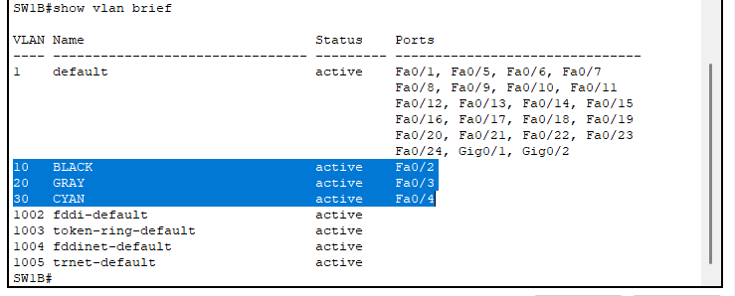
Switch2
SW2B(config)#interface FastEthernet0/2
SW2B(config-if)#switchport mode access
SW2B(config-if)#switchport access vlan 10
SW2B(config-if)#interface fastethernet 0/3
SW2B(config-if)#switchport mode access
SW2B(config-if)#switchport access vlan 20
SW2B(config-if)#interface fastethernet 0/4
SW2B(config-if)#switchport mode access
SW2B(config-if)#switchport access vlan 30
SW2B(config-if)#exit
SW2B(config)#exit
SW2B#
%SYS-5-CONFIG_I: Configured from console by console
SW2B#show vlan brief
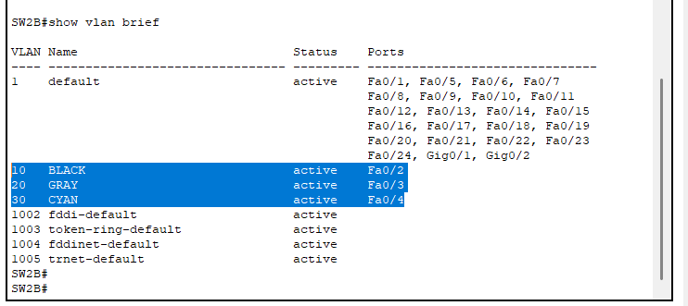

3. Configure the Trunk Mode – Configure the mode trunk to all interface
of the switches that connects to another switches
switch1
SW1B(config)#interface FastEthernet0/1
SW1B(config-if)#switchport mode trunk

SW1B(config-if)#
%LINEPROTO-5-UPDOWN: Line protocol on Interface FastEthernet0/1, changed state to down

%LINEPROTO-5-UPDOWN: Line protocol on Interface FastEthernet0/1, changed state to up
SW1B(config-if)#exit
SW1B(config)#exit

Switch 2
SW2B(config)#interface FastEthernet0/1
SW2B(config-if)#switchport mode trunk
SW2B(config-if)#switchport nonegotiate
SW2B(config-if)#exit
%LINEPROTO-5-UPDOWN: Line protocol on Interface FastEthernet0/1, changed state to down

%LINEPROTO-5-UPDOWN: Line protocol on Interface FastEthernet0/1, changed state to up
SW2B(config)#exit
4. Configure Trunk on Native VLAN 1 on both switch
Switch1
SW1B(config)#interface FastEthernet0/24
SW1B(config-if)#switchport mode trunk
SW1B(config-if)#switchport trunk native vlan 1
SW1B(config-if)#exit
Switch2
SW2B(config)#interface FastEthernet0/24
SW2B(config-if)#switch mode trunk
SW2B(config-if)#switchport trunk native vlan 1
SW2B(config-if)#exit

5. Configure the IP address and subnet mask on the PCs as follows. There is no layer three device on the network so the default gateway will not be configured.
VLAN 10: 192.168.10.0/24
VLAN 20: 192.168.20.0/24
VLAN 30: 192.168.30.0/24
PC0: 192.168.10.110
PC2:192.168.20.220
PC1: 192.168.30.30
PC3: 192.168.10.111
PC4: 192.168.20.221
PC5: 192.168.30.31
Result:
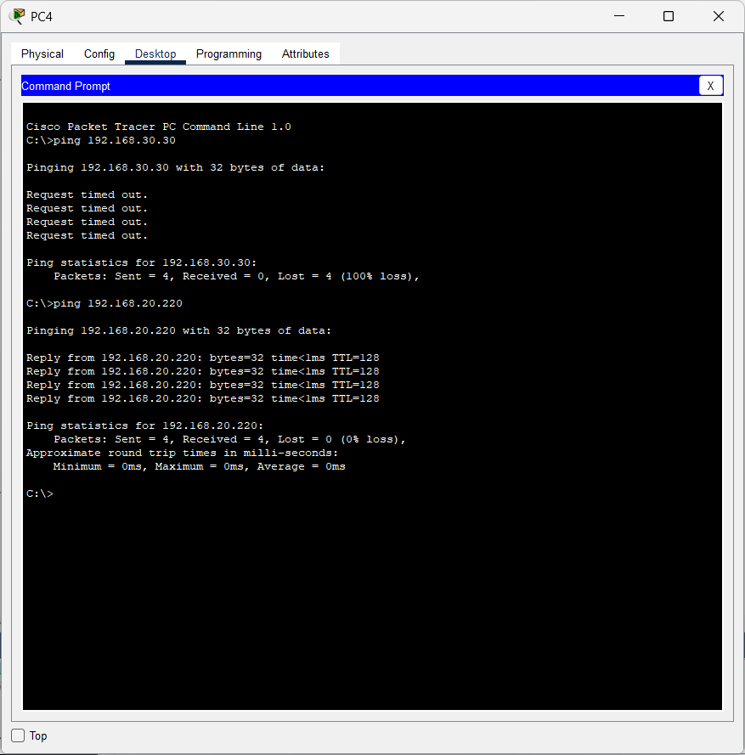

LAB 7: Implementation of RIP, EIGRP, OSPF and BGP

Objective
To implement and understand the operation of the following routing protocols:
- RIP (Routing Information Protocol)
- EIGRP (Enhanced Interior Gateway Routing Protocol)
- OSPF (Open Shortest Path First)
- BGP (Border Gateway Protocol)

Background:
Routing Protocols are the set of defined rules used by routers to communicate between source and destination networks. They do not directly move the information from the source to the destination but help update and maintain the routing table, which contains all necessary path information. Routing protocols determine the best possible route for packet forwarding based on metrics such as hop count, cost, bandwidth, delay, and other parameters.
Routing protocols are broadly classified into IGP (Interior Gateway Protocols) and EGP (Exterior Gateway Protocols).

Router Configuration
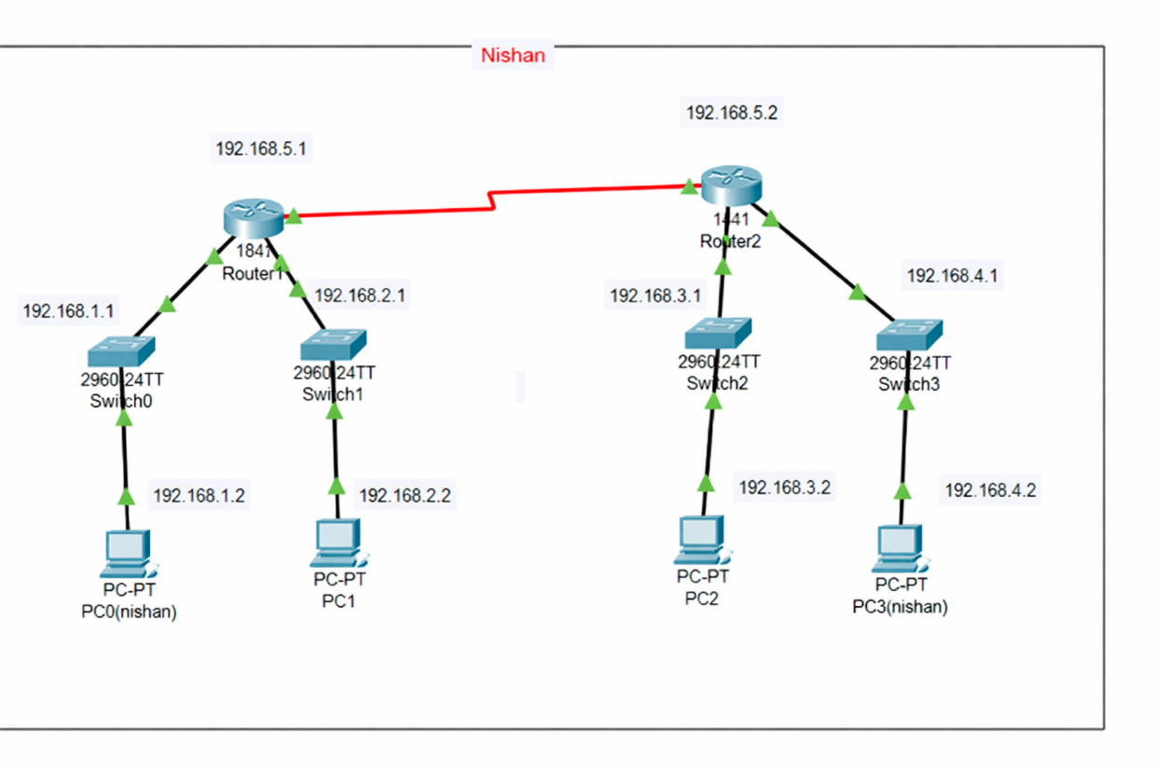

Serial Link Configuration

Router 1

Router(config)#hostname Nishan

Nishan(config)#interface s0/0/0

Nishan (config-if)#ip address 192.168.5.1 255.255.255.0

Nishan (config-if)#clock rate 64000

Nishan (config-if)#bandwidth 1024

Nishan (config-if)#no shutdown

Router 2

Router(config)#hostname NishanR2

NishanR2(config)# interface serial 0/0/0

NishanR2(config-if)#ip address 192.168.5.2 255.255.255.0

NishanR2(config-if)#no shutdown

NishanR2(config-if)#exit

Other Interfaces

Router 1

Nishan (config)#interface fastethernet 0/0

Nishan (config-if)#ip address 192.168.1.1 255.255.255.0

Nishan (config-if)#no shutdown

Nishan (config-if)#interface fastethernet 0/1

Nishan (config-if)#ip address 192.168.2.1 255.255.255.0

Nishan (config-if)#no shutdown

Nishan (config-if)#exit

Nishan (config)#exit

Router 2

NishanR2(config)#interface fastethernet 0/0

NishanR2(config-if)#ip address 192.168.3.1 255.255.255.0

NishanR2(config-if)#no shutdown

NishanR2(config-if)#interface fastethernet 0/1

NishanR2(config-if)#ip address 192.168.4.1 255.255.255.0

NishanR2(config-if)#no shutdown

NishanR2(config-if)#exit

NishanR2(config)#exit

RIP Implementation
Router 1
Nishan(config)#router
Nishan(config-router)#network 192.168.1.0
Nishan(config-router)#network 192.168.2.0
Nishan(config-router)#network 192.168.3.0
Nishan(config-router)#network 192.168.4.0
Nishan(config-router)#network 192.168.5.0
Nishan(config-router)#exit
Nishan(config)#exit
Nishan#show run

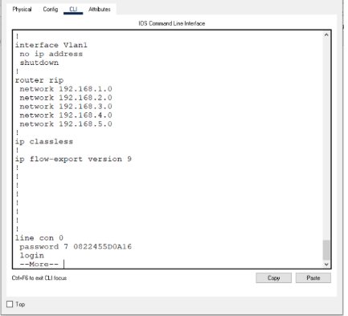

Router 2
NishanR2(config)#router rip
NishanR2(config-router)#network 192.168.1.0
NishanR2(config-router)#network 192.168.2.0
NishanR2(config-router)#network 192.168.3.0
NishanR2(config-router)#network 192.168.4.0
NishanR2(config-router)#network 192.168.5.0
NishanR2(config-router)#exit
NishanR2(config)#exit
NishanR2#show run


Verify connections
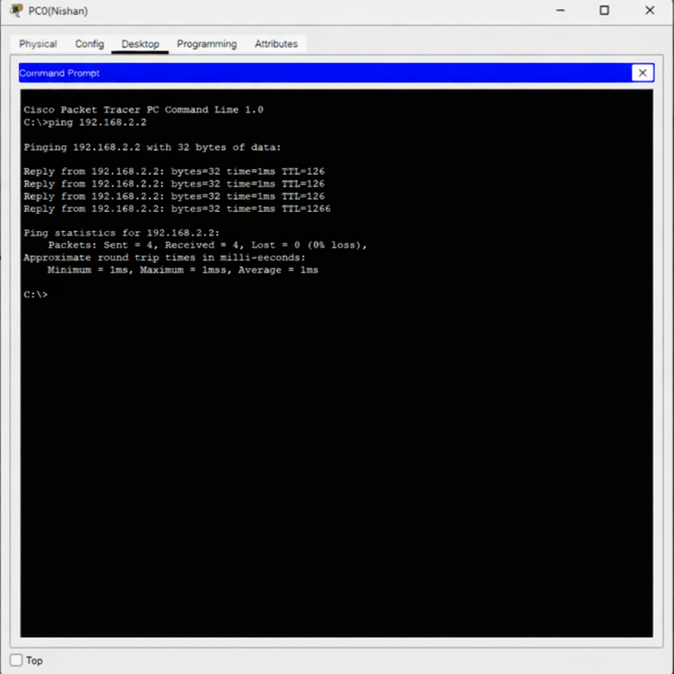

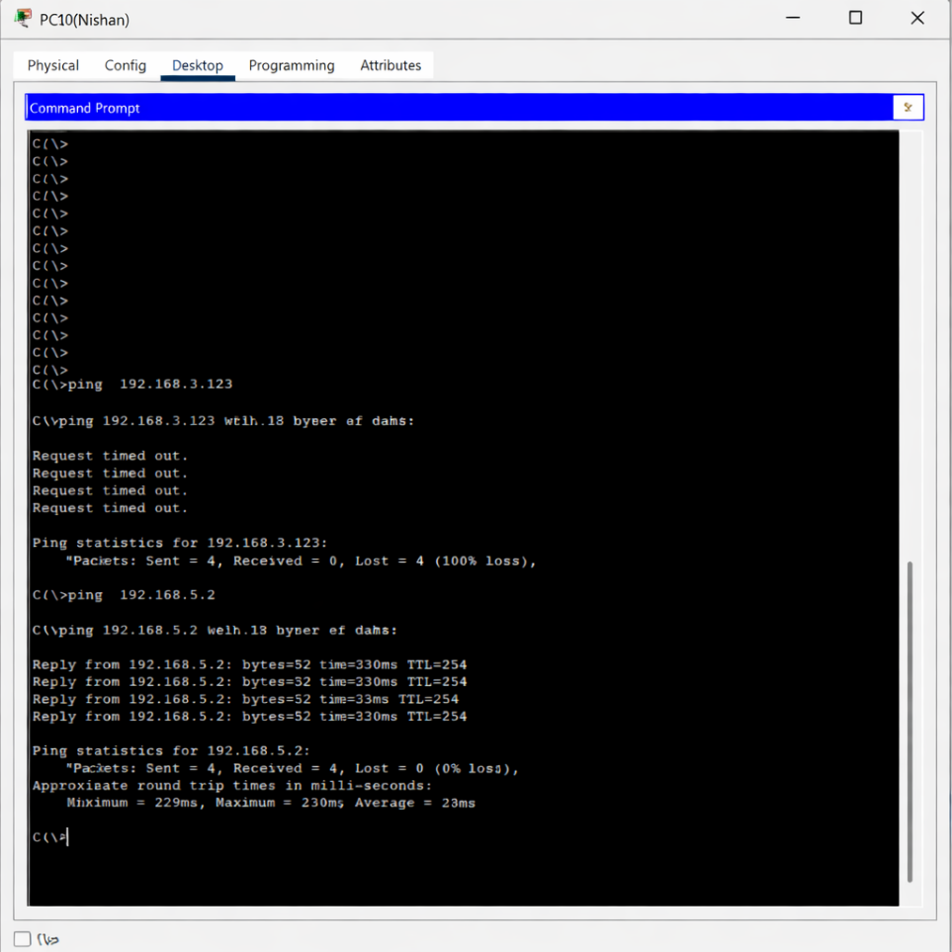
EIGRP (Enhanced Interior Gateway Routing Protocol)
Router 1
Nishan(config)#no router rip
Nishan(config)#router eigrp 343
Nishan(config-router)#network 192.168.1.0
Nishan(config-router)#network 192.168.2.0
Nishan(config-router)#network 192.168.3.0
Nishan(config-router)#network 192.168.4.0
Nishan(config-router)#network 192.168.5.0
Nishan(config-router)#exit
Router 2
NishanR2(config)#no router rip
NishanR2(config)#router eigrp 343
NishanR2(config-router)#network 192.168.1.0
NishanR2(config-router)#network 192.168.2.0
NishanR2(config-router)#network 192.168.3.0
NishanR2(config-router)#network 192.168.4.0
NishanR2(config-router)#network 192.168.5.0
NishanR2(config-router)#exit
OSPF Implementation
Router 1
Nishan(config)#no router eigrp 343
Nishan(config)#router ospf 343
Nishan (config-router)#network 192.168.1.0 0.0.0.255 area 0
Nishan (config-router)#network 192.168.2.0 0.0.0.255 area 0
Nishan (config-router)#network 192.168.3.0 0.0.0.255 area 0
Nishan (config-router)#network 192.168.4.0 0.0.0.255 area 0
Nishan (config-router)#network 192.168.5.0 0.0.0.255 area 0
Nishan (config-router)#exit

Router 2
NishanR2(config)#no router eigrp 343
NishanR2(config)#router ospf 343
NishanR2(config-router)#network 192.168.1.0 0.0.0.255 area 0
NishanR2(config-router)#network 192.168.2.0 0.0.0.255 area 0
NishanR2(config-router)#network 192.168.3.0 0.0.0.255 area 0
NishanR2(config-router)#network 192.168.4.0 0.0.0.255 area 0
NishanR2(config-router)#network 192.168.5.0 0.0.0.255 area 0
NishanR2(config-router)#exit

LAB 8: Firewall Implementation, Router Access Control List (ACL)

Objective(s):
- To understand the concept of router firewalls using Access Control Lists (ACLs).
- To implement packet filtering using Standard and Extended ACLs on Cisco routers.

Background:
At the network layer, packet filtering is commonly achieved using Access Control Lists (ACLs) configured on routers. When ACLs are applied, the router functions like a basic firewall by selectively permitting or denying packets based on defined rules.
ACLs allow network administrators to:
- Control unwanted network traffic.
- Restrict access to specific hosts or networks.
- Enhance security by blocking unauthorized communication.
ACLs inspect packets based on:
- Source IP/network
- Destination IP/network
- Protocols (IP, TCP, UDP)
- Ports or services (for extended ACLs)
Without ACLs, routers permit all traffic by default. Filtering occurs only when ACL rules are applied.

Types of ACLs
1. Standard ACL
Standard ACLs filter traffic based only on the source IP address.
- Valid ACL number range: 1–99
- Should be applied closest to the destination
- Can:
  - Permit or deny source IP addresses only
Standard ACLs are best when simple source-based filtering is needed.

2. Extended ACL
Extended ACLs provide more granularity. They can filter packets based on:
- Source IP Address
- Destination IP Address
- Protocol (IP/TCP/UDP/ICMP)
- Port numbers or services (HTTP, FTP, Telnet, etc.)
- Valid ACL number range: 100–199
- Should be applied closest to the source
Extended ACLs are used for fine-grained traffic control, such as blocking specific services or protocols.

Important Notes About ACLs
- ACLs may be identified using either numbers or names, depending on the protocol.
- The identifying number must fall within the valid range for that ACL type.
- ACLs consist of a series of permit or deny statements evaluated top-to-bottom.
- There is an implicit “deny any” rule at the end of every ACL, even if it is not visible.
- ACLs can filter traffic:
  - Inbound (when packets enter the interface)
  - Outbound (when packets exit the interface)
When a packet arrives at the router, the ACL determines whether the packet will be forwarded or blocked based on whether it matches the configured rules.

Configurations

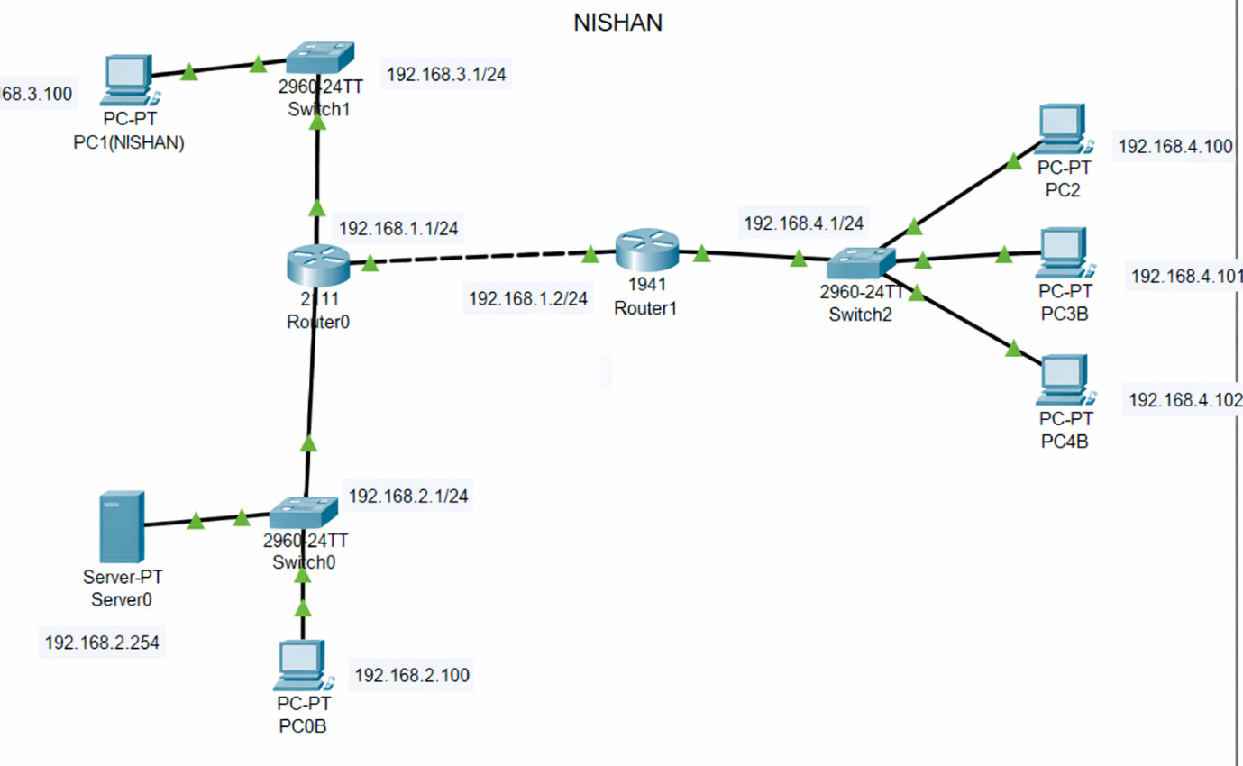

LAB 09: DHCP, WEB,DNS, EMAIL, FTP Server Configuration

Router Interface Configuration
• Go to router and assign static ip addresses

Router>enable
Router#configure terminal
Enter configuration commands, one per line. End with CNTL/Z.
Router(config)#hostname NishanR
NishanR(config)#
NishanR(config)#int g0/0
NishanR(config-if)#ip address 192.168.1.1 255.255.255.0
NishanR(config-if)#no shutdown

NishanR(config-if)#
%LINK-5-CHANGED: Interface GigabitEthernet0/0, changed state to up

%LINEPROTO-5-UPDOWN: Line protocol on Interface GigabitEthernet0/0, changed state to up

NishanR(config-if)#int g0/1
NishanR(config-if)#ip address 192.168.2.1 255.255.255.0
NishanR(config-if)#no shutdown

NishanR(config-if)#
%LINK-5-CHANGED: Interface GigabitEthernet0/1, changed state to up

%LINEPROTO-5-UPDOWN: Line protocol on Interface GigabitEthernet0/1, changed state to up
DHCP helper configuration in the Router
• Enable ip helper-address in the router for DHCP
NishanR(config)#interface GigabitEthernet0/0
NishanR(config-if)#ip helper-address 192.168.2.2
NishanR(config-if)#

DHCP Server Configuration
• Assign the static ip address to the server
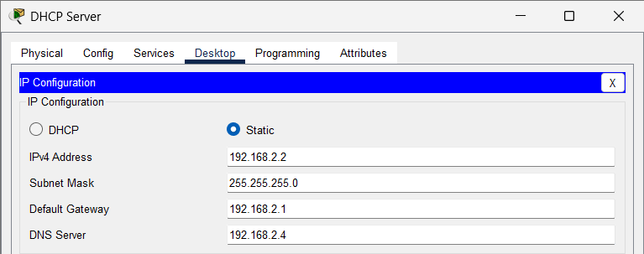
• Turn ON the DHCP service and create the server pool as follows
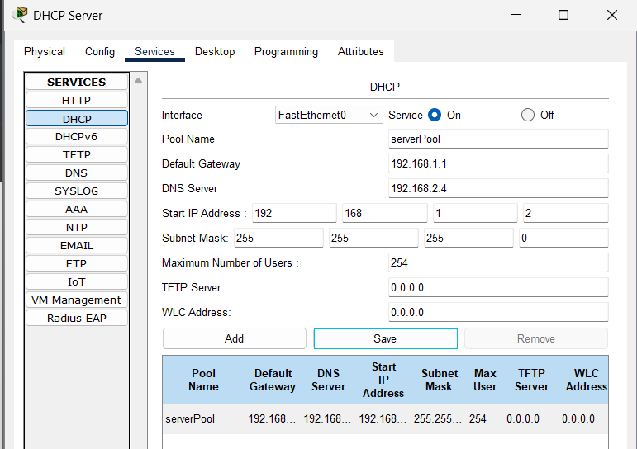
Assign Dynamic IP Configuration to PC0 and PC1
• Go to PC0(Nishan)>Desktop>IP Configuration then select DHCP
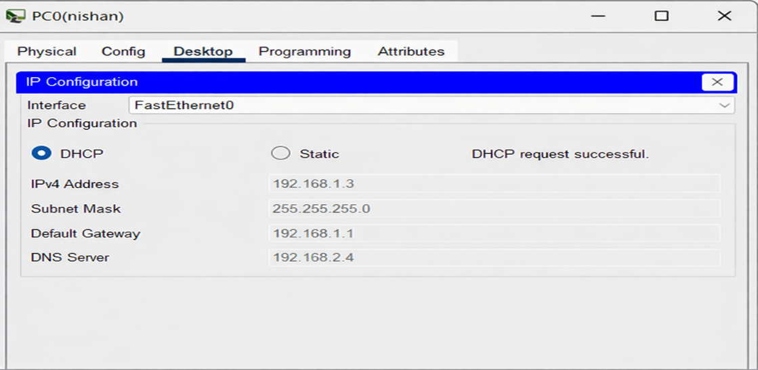

• Go to PC1(Nishan)>Desktop>IP Configuration then select DHCP
HTTP Server
• Assign static ip address to the HTTP server
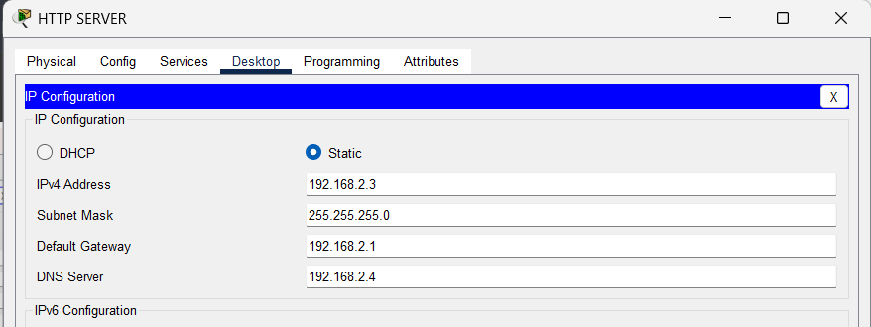

• Make sure to turn ON the HTTP Service
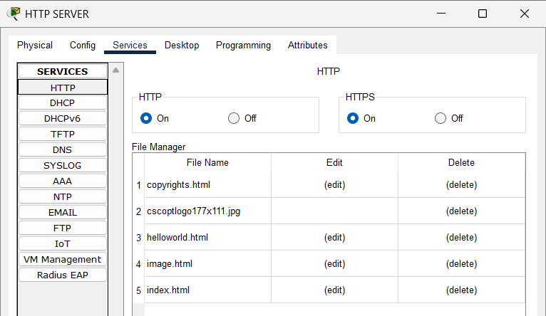

DNS Server Configuration
• Assign the static ip address to the DNS server
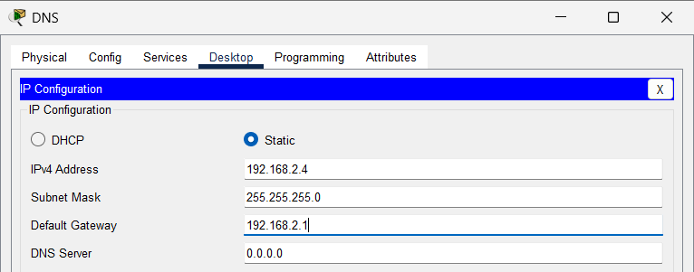

• Add DNS Records of the domain name (eg. www.testserver.com)

• Go to PC0>Desktop>Web browser and open the url

EMAIL Server Configuration
• Assign the static ip address to the EMAIL server
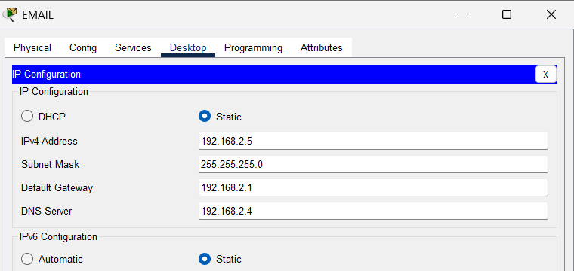

• Turn ON the SMTP and POP3 services and create two users

• Go to PC0>Email>Configure user as follows

• Go to PC1>Email>Configure user as follows

• Go to PC0>Desktop>Email and compose the email as follows

• Go to PC1>Desktop>Email and check (receive) email as follows

FTP Server Configuration
• Assign static ip address to the FTP server as follows
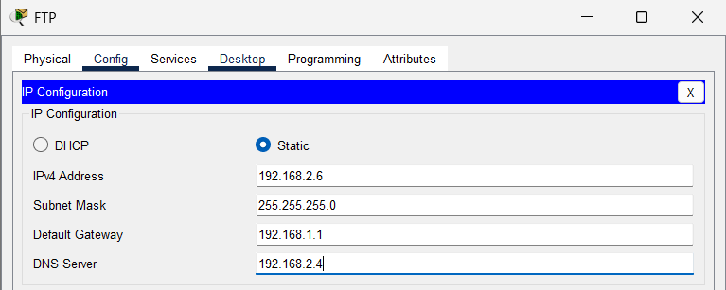
• Enable the FTP service and create two users: admin (with write ,read, delete, rename, list options) and user (with read and list only)

• Go to PC0>Desktop>Text Editor, create a file testb1.txt and save it on the desktop

• Go to Desktop>Command Prompt and verify the created file using dir command then login into the ftp server as follows using admin user and password

• Use PUT command to upload test.txt into the FTP Server as follows:
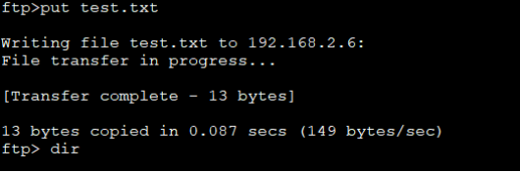

Verify the uploaded file using the command dir
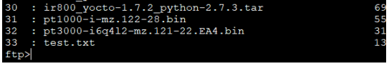

Go to PC1>Desktop>Command Prompt, connect to the FTP server using user account and password and use GET command to download file test.txt into the desktop. After the transfer type dir command to verify it.
